VBCS TENANT Database Switch

Table of Contents
Audience: 1
Pre-Requisite: 1
Wallet File 1
Change the Tenant Database of VBCS 1
Oracle Cloud Infrastructure Console (Login) 1
Oracle Integration Cloud Service Console (Direct URL) 1

Audience:

- Database Admins
- Integration Admins.
- Infrastructure Admin

Pre-Requisite:

These steps must be performed on each integration instance of the Oracle integration cloud console (oicdev, oicdit,) and will require Database Admins (Wallet File, Admin Password) and Infrastructure Admins (Load Balancer IP (Internet Protocol))

- Integration instance Service Roles are mapped to the OCI groups (Refer to the OCI Playbook for details on assigning)
- Ensure that the support member, performing has the Integration Admin Role to the User (Refer to the OCI Playbook for details on assigning)
- ATP (Autonomous Transaction Processing) Database Wallet file, Wallet password, Admin user, and the password
- Obtain the Load Balancer IP
- Modify the Wallet File to point to the Load Balancer IP

Wallet File

Oracle ATP database is provisioned in the OCI VCN (Virtual Cloud Network) subnet that is private. Wallet (zip) file contains tnsnames.ora file with a hostname that is resolvable and reachable only from within the private network. A public load balancer is created (Network load balancer) which is set to allow traffic from the visual builder cloud services network alone. However, the Public Load balancer IP needs to be entered into the tnsnames.ora against the hostname field against the various services listed in the file (manually). The wallet file needs to be zipped back again to be used in the subsequent steps.

Steps
- Download the Wallet file from the ATP database.
- Unzip the contents of the Wallet File
- Edit the tnsnames.ora and modify the hostname to point to the Load Balancer IP (Each database is provisioned with the corresponding Load balancer

Change the Tenant Database of VBCS

You can directly login to the OIC instance environment or go through OCI cloud console

Oracle Cloud Infrastructure Console (Login)

Login into the ocis tenancy and using the domain, login in as a user with assigned integration admin role.

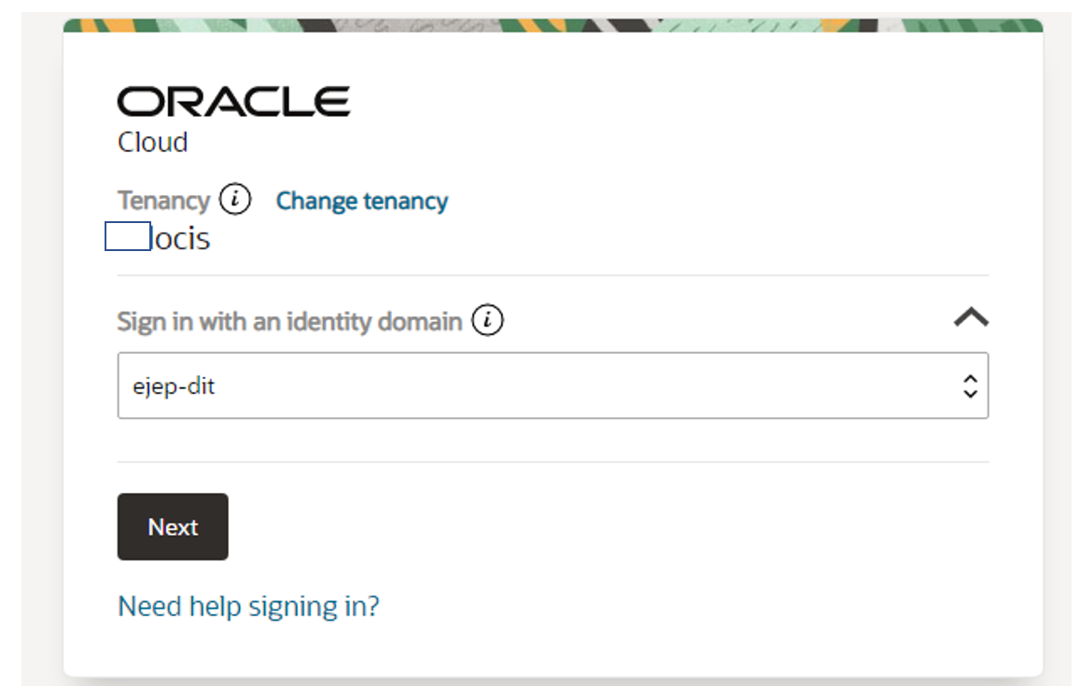

Navigate -> Developer Services -> Application Integration -> Integration.
Switch to compartment ocis:nonprod:nonprod_tst:apptst to display the oic instance.

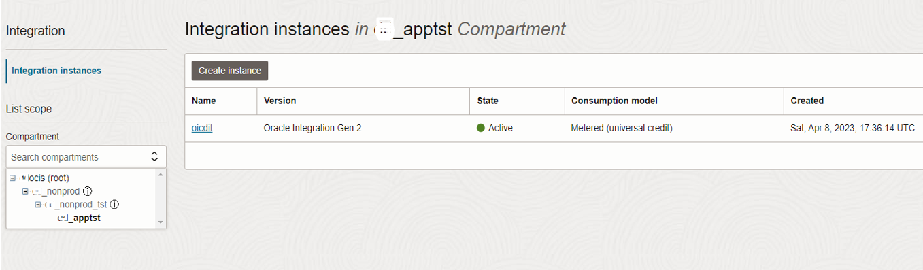

Click on the OIC service instance to display the service details.

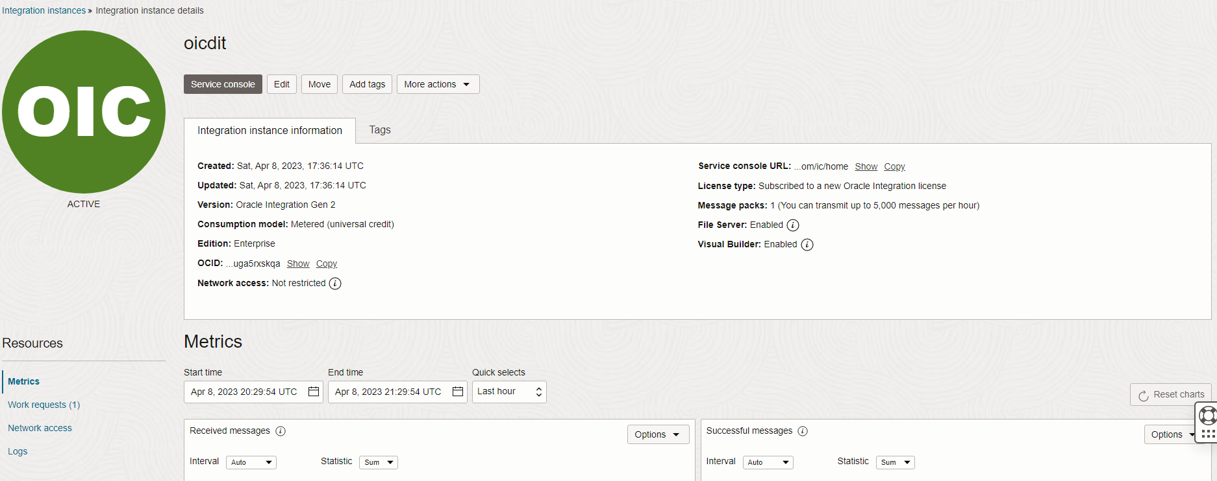

Click on the Service console button to launch the OIC instance.

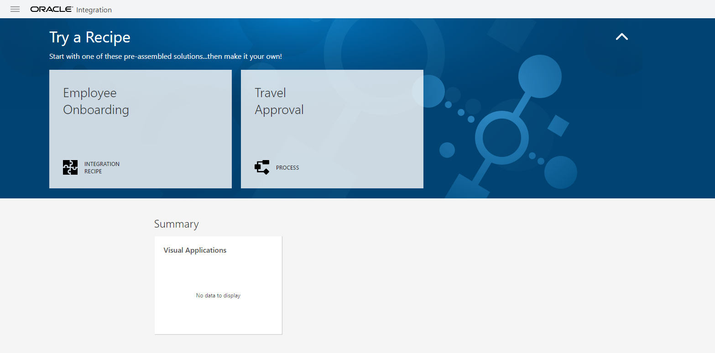

Oracle Integration Cloud Service Console (Direct URL)

To navigate to the above UI (User Interface), you can use the below URL for oic (for other environments, the prefix will be oicdev, oicmot, etc.)

https://oicdit-axsfjwifuy3i-sj.integration.ocp.oraclecloud.com/ic/home/

In the service console of OIC, Navigate -> Visual Builder -> display the Visual Builder Applications Page.

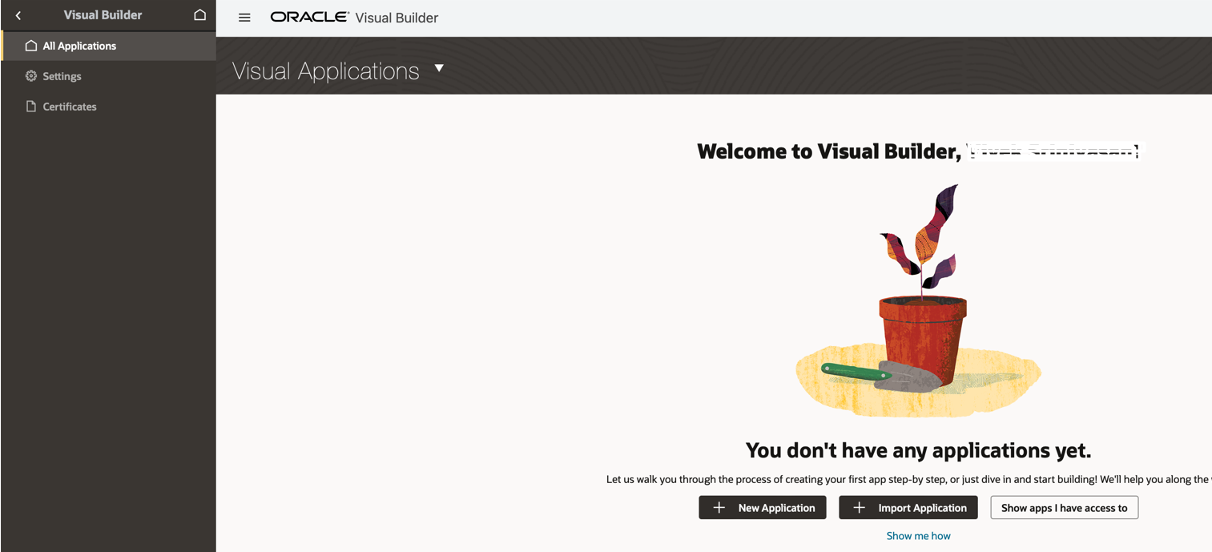

Click on Settings to navigate to the Settings page. In the Setting page, click on the Tenant database.

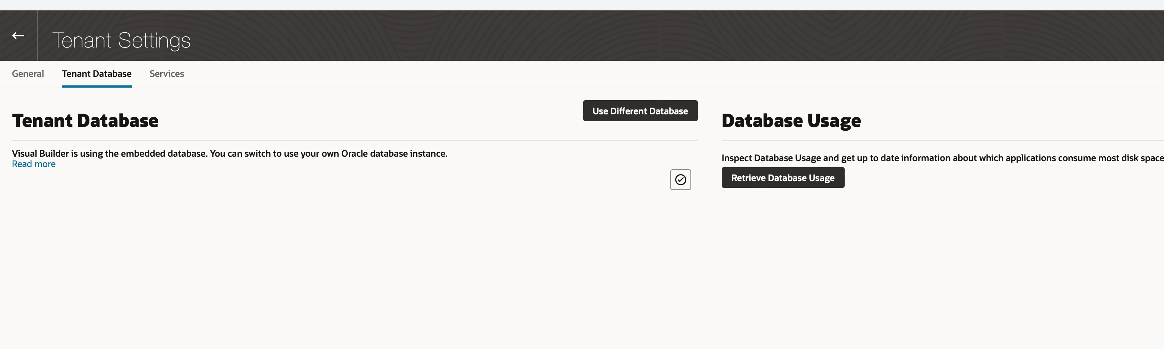

Click on the “Use Different Database” link and configure the ATP database.

Connection Type: Oracle Autonomous Transaction Database

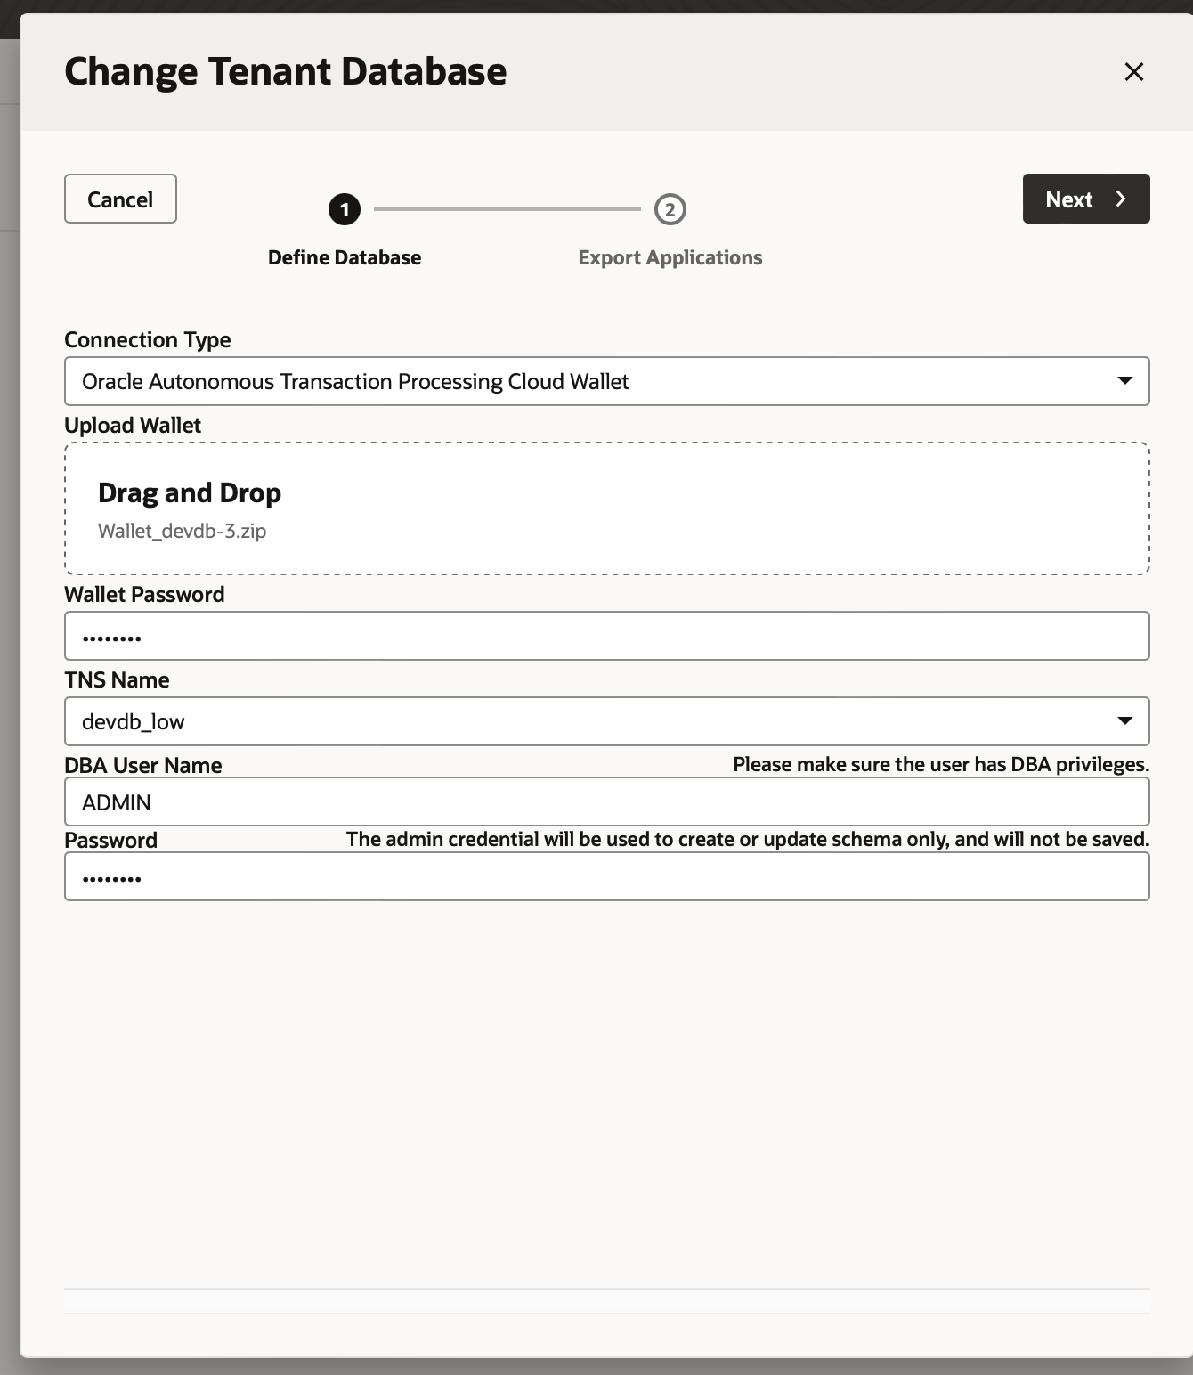

Click NEXT and complete the switching of the Tenant Database of VBCS

